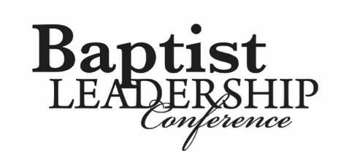

**Assuming the Pastorate of a Small, Struggling Church**

*Dr. Gary W. Winters*

Planting and Replanting Churches in America

Today’s session will address the challenge of **replanting a Church** that has 20-35 in attendance and has less than $1,000 per week average offerings. By way of illustration, we will define and **discuss** replanting a tree or plant without losing the plant due to “shock,” “wilting,” or death.

7 Key Areas of Priority for the Replanting of a Church

1. Constitution and By-laws, which includes your Doctrinal Statement
2. Church budget
3. Music
4. Sunday School Department organization
5. Soul winning outreach
6. Missions
7. Ushers count list

**Conclusion**:

1. 38% of all trees have been replanted.
2. Replant only those trees with a healthy root system.
3. Choose a good location with good soil and water often.

7 Issues that You **Could** Face When Replanting a Small Church:

1. The King James Bible issue—*this must be settled before replanting is considered*.
2. Soul winning
3. Standards for S.S. teachers and all Church workers (the standards are for teachers, officers, and workers)
4. Acts 1:8 Missions issue
5. Church camps, Bible colleges, Church conferences, etc.
6. The Diotrephes issue found in III John 9 (a small church often has a man “…*who loveth to have the preeminence*.”)
7. Making the Pastor your #1 Missionary (pay the Pastor something before you try to add 25 missionaries)